Describe the roles and responsibilities of the angels in the light of Quran from

the verses and Surahs we have studied in Angels topic. With reference to

Quranic verses (Arabic context) along with their English/Urdu translation.

In the light of the Quranic verses, we can determine several roles and responsibilities of angels as outlined in Islamic theology:

**1. Messengers of Allah:** Angels are described as messengers of Allah, delivering His commands and revelations to His chosen servants. They serve as intermediaries between Allah and humanity, conveying His messages with utmost obedience and precision.

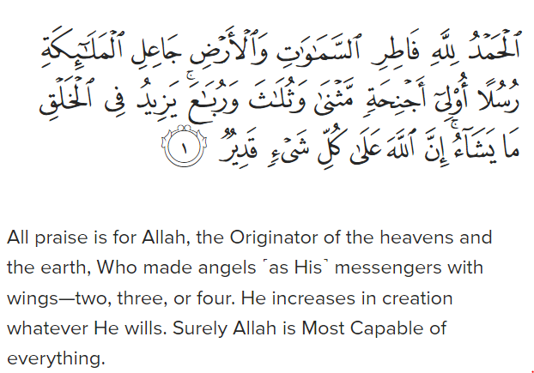Surah Fatir (35:1)

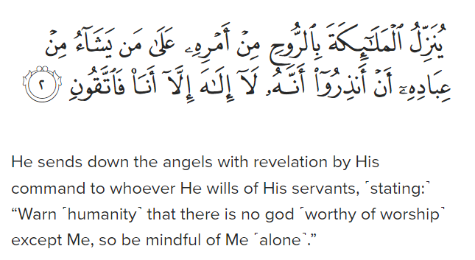Surah An-Nahl (16:2)

**2. Glorification and Worship of Allah:** Angels continuously glorify and worship Allah, both individually and collectively. They carry out these acts of worship with utmost humility and devotion, never showing arrogance or disobedience (Surah Al-A'raf, 206).

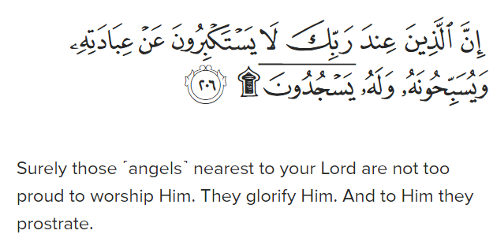Surah Al-A’raf (7:206)

**4. Recording Deeds**: Honourable angels are assigned the task of meticulously recording the deeds of every individual. They observe and document all actions, ensuring absolute accountability on the Day of Judgment.

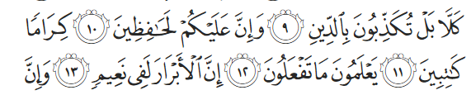

But no! In fact, you deny the ˹final˺ Judgment, while you are certainly

observed by vigilant, honourable angels, recording ˹everything˺.

They know whatever you do. Surah Al-Intifitar (82:9-12)

**5. Protection and Support for Believers:** Angels descend upon the steadfast believers, offering them reassurance, protection, and glad tidings of Paradise. They provide support to the believers in this world and the Hereafter, serving as allies and guardians.

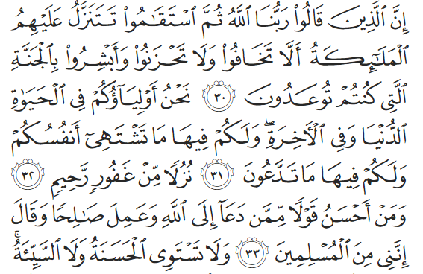

Surely those who say, “Our Lord is Allah,” and then remain steadfast,

the angels descend upon them,1 ˹saying, ˺ “Do not fear, nor grieve.

Rather, rejoice in the good news of Paradise, which you have

been promised. We are your supporters in this worldly life and

in the Hereafter. There you will have whatever your souls desire,

and there you will have whatever you ask for: an accommodation

from the All-Forgiving, Most Merciful ˹Lord˺. And whose words

are better than someone who calls ˹others˺ to Allah, does good,

and says, “I am truly one of those who submit.”? Surah Fussilat (41:30-33)

**6. Carrying the Throne of Allah:** Some angels are tasked with carrying the Throne of Allah and glorifying His praises. They seek forgiveness for the believers and supplicate for their well-being, demonstrating Allah's mercy and compassion.

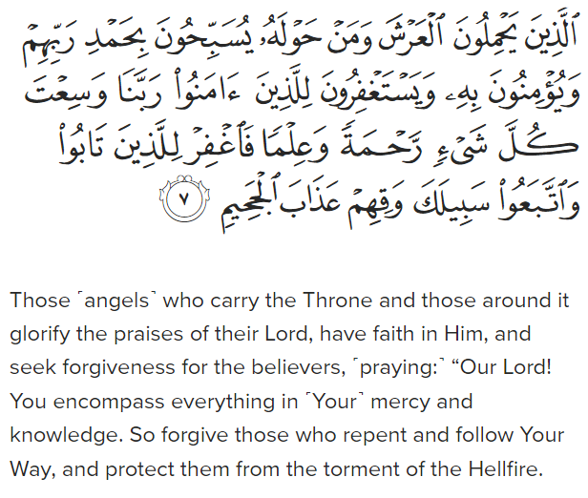Surah Ghafir (40:7)

**7. Revelation and Warning:** Angels are responsible for delivering revelations from Allah to His chosen messengers. They warn humanity of the consequences of disbelief and urge them to worship Allah alone, fulfilling their duty to convey His message.

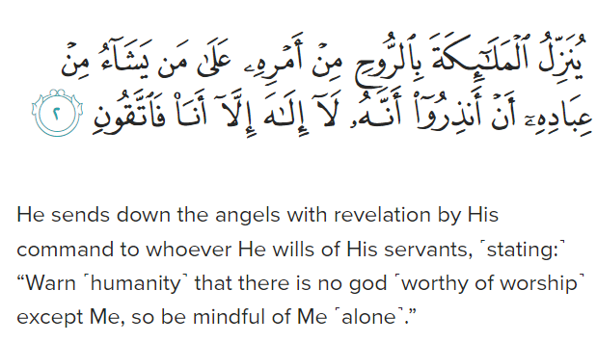Surah Al-Nahl (16:2)

**8. Participation in Significant Events:** Angels play a role in significant events such as the Night of Glory (Laylat al-Qadr), descending to Earth with divine decrees and blessings. They participate in pivotal moments as per Allah's command, ensuring the fulfilment of His divine plan.

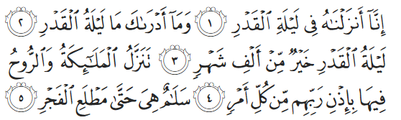

Indeed, ˹it is˺ We ˹Who˺ sent this ˹Quran˺ down on the Night

of Glory. And what will make you realize what the Night of

Glory is? That night the angels and the ˹holy˺ spirit1 descend

, by the permission of their Lord, for every ˹decreed˺

matter. It is all peace until the break of dawn. Surah Al-Qadr (1-5)

These verses collectively highlight the multifaceted roles and responsibilities of angels in Islam, emphasizing their unwavering devotion to Allah, their obedience to His commands, and their integral role in facilitating communication between the Divine and humanity.